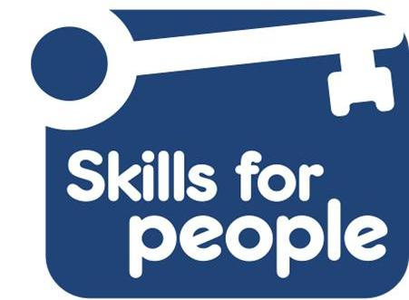
Skills for People Application Form

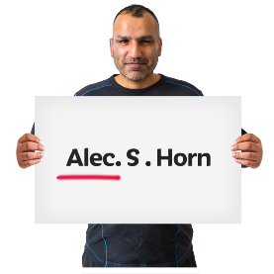 | What is your name?
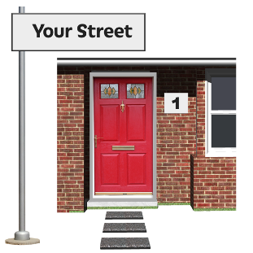 | What is your address?
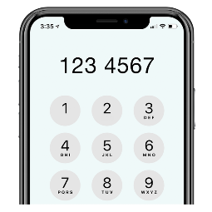 | What is your phone number?
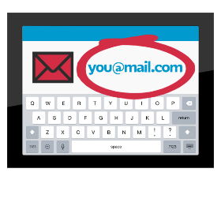 | What is your email address?
 | Tell us places you have worked or volunteered, including the start and end dates:
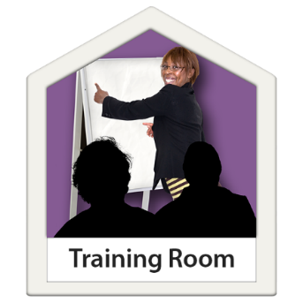 | What training have you had that might help you to do this job?
 | Tell us why you are the best person for the job.  Please look at the Job Description. It tells you what kind of person we are looking for.  Tell us as much as you can about what skills, experience and knowledge you have. Use examples from your experience.  You need to show us that you have skills and experience of as many things as possible, from the list in the Job Description.
Write your answer here. You can add one extra page if you need to.

 | Do you have a learning disability, are you an autistic person or both? Tick a box:
Learning disability

Autistic person

Both

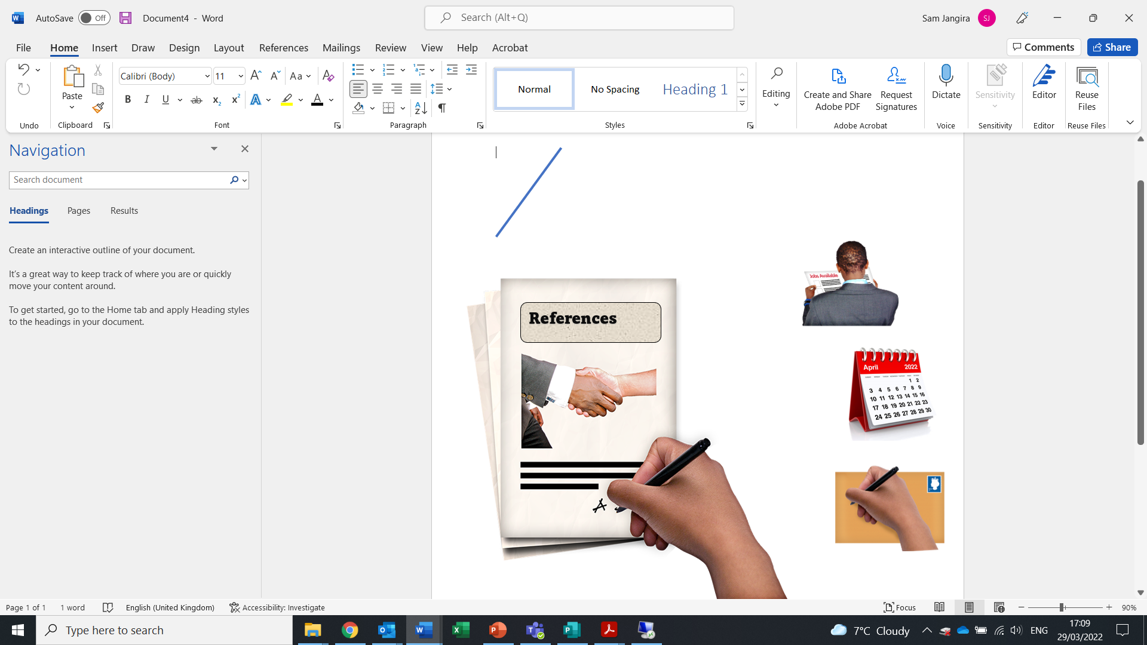 | Please tell us two people who can write a reference for you.  Name:  Address:  Email:  Phone  How do you know them?
Name:

Address:

Email:

Phone

How do you know them?

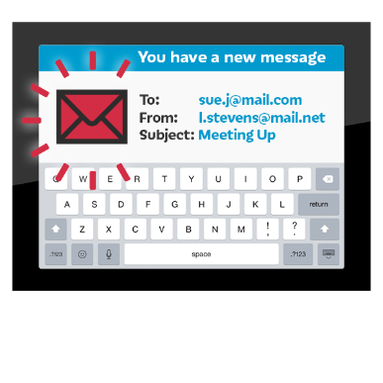 | If you have any questions about the job  Please contact  Sara Harris  by email: sara.harris@skillsforpeople.org.uk  or phone 0191 281 8737

  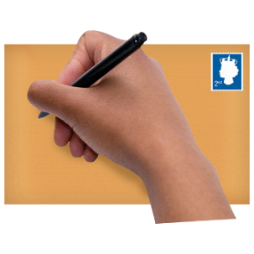 | Please send your completed form by email or post  sara.harris@skillsforpeople.org.uk  Sara Harris  Skills for People  4 Glendale Terrace  Newcastle upon Tyne  NE6 1PB

