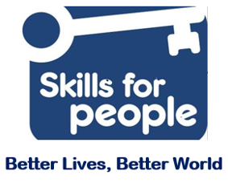

Equality Monitoring Form
Skills for People wants to meet the aims and commitments set out in its equality policy. This includes not discriminating under the Equality Act 2010, and building a picture of the make-up of our workforce to encourage equality and diversity.

We need your help and co-operation to do this, but filling in this form is voluntary. The information provided will be kept confidential and will be used for monitoring purposes. If you have any questions about the form, contact jobs@skillsforpeople.org.uk.

Please return the completed form with your application to jobs@skillsforpeople.org.uk.

Please mark in the box which best describes you.

Gender:
Male | Female | Non binary
Intersex | Prefer not to say

If you prefer to use your own gender identity, please write in:

Is the gender you identify with the same as your gender registered at birth?
Yes | No | Prefer not to say

Age:
16-24 | 25-29 | 30-34
35-39 | 40-44 | 45-49
50-54 | 55-59 | 60-64
65+ | Prefer not to say

What is your ethnicity?
Ethnic origin is not about nationality, place of birth or citizenship. It is about the group to which you believe you belong.

Asian or Asian British
Indian | Pakistani | Bangladeshi
Chinese | Prefer not to say
Any other Asian or Asian British background, please write in:

Black, African, Caribbean or Black British
African | Caribbean | Prefer not to say
Any other Back, African or Caribbean background, please write in:

Mixed or Multiple ethnic groups
White and Black Caribbean | White and Black African | White and Black Asian
Any other Mixed or Multiple ethnic background, please write in:

White
English | Welsh | Scottish
Northern Irish | Irish | British
Gypsy or Irish Traveller | Prefer not to say
Any other White background, please write in:

Other ethnic group
Arab | Prefer not to say
Any other ethnic group, please write in:

Do you consider yourself to have a disability or health condition?
Yes | No | Prefer not to say

What is the effect or impact of your disability or health condition on your work? Please write in here:

What is your sexual orientation?
Heterosexual | Gay | Lesbian
Bisexual | Asexual | Pansexual
Undecided | Prefer not to say
If you prefer to use your own identity, please write in:

What is your religion or belief?
No religion or belief | Buddhist | Christian
Hindu | Jewish | Muslim
Sikh | Prefer not to say
Any other religion or belief, please write in:

Where did you hear about this job/position?

