Your home address
Your home address
Your home address
Your MPs address
Your MPs address
Your MPs address
Today’s date
Dear

 | As my MP, I am writing to you about this important issue, as you are my voice in Parliament.
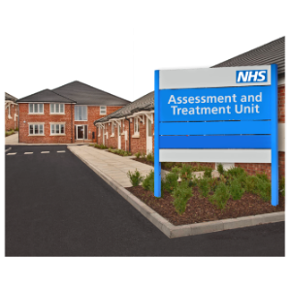 | I am angry and upset that over 2,000 people with learning disabilities, and/or autistic people, are living in Assessment and Treatment Units.
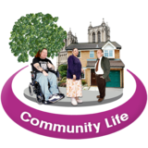 | People are only meant to be in Assessment and Treatment Units for a short time, before moving back into the community.
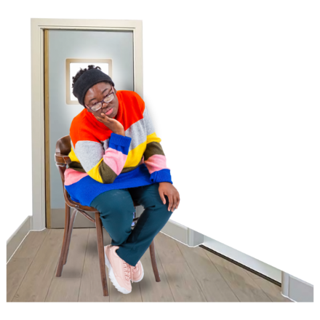 | However, some people can live in them for years.
 | I am angry and upset that some people in Assessment and Treatment Units are being abused, by people who are meant to support them.
 | There have been some incidents of abuse that lots of people heard about, such as Winterbourne View in 2011, and Whorlton Hall in 2019.
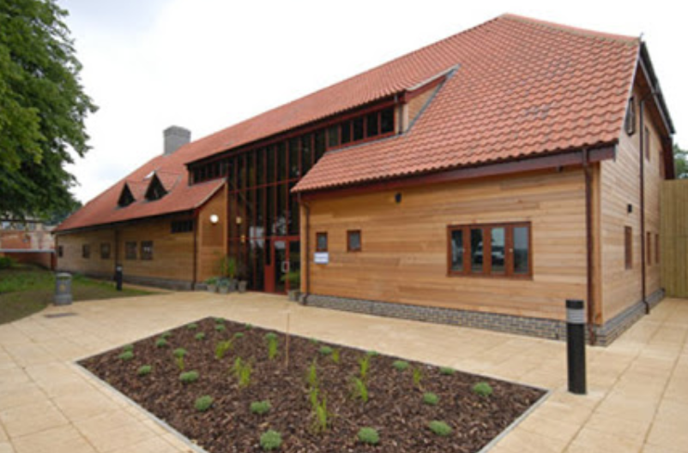  Photo credit: Priory Group | There have also been some incidents of abuse that not many people have heard about, such as St John’s House in Suffolk in 2021.
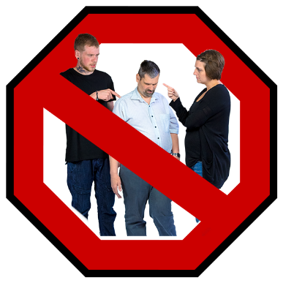 | I feel sick, angry and upset about this.  This abuse needs to stop.
Less people should be in Assessment and Treatment Units, or secure hospitals.

People should be supported to live in the community instead.

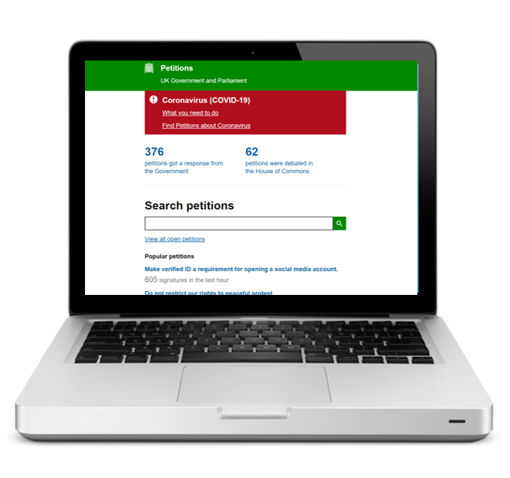 | We Are Human Too have created a petition.  It asks that a user-led, independent body is created, to support the Care Quality Commission to monitor secure settings, such as hospitals and Assessment and Treatment Units, and hold them to account.  https://petition.parliament.uk/petitions/588300
 | ATUs should be places where people are supported to get through a crisis, before going back to their communities. Not places to be abused.
 | I am asking you to support this petition, and share it with people you know.
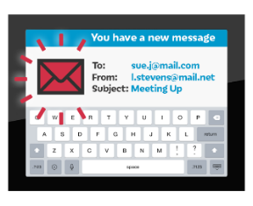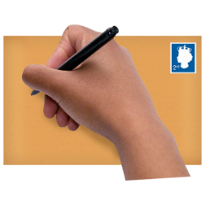 | Please could you reply to me, and let me know how you can support this campaign?  Please reply to me within 14 days.

With thanks

Your name

This letter has been created by We Are Human Too. This is a group of self-advocates, made up of people with learning disabilities and autistic people, from the North East of England.
Find out more about our work: https://youtu.be/fbFRu6VRov0

