Your name
Address
Town
Postcode
Service provider
Address
Town
Postcode

Date

Dear [person’s name],

 | NHS England published the Accessible Information Standard in 2016.
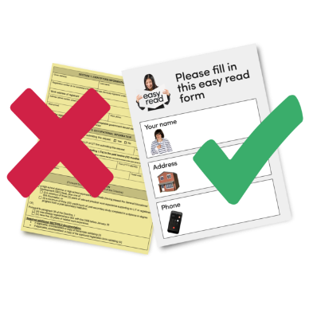 | This sets out rules for accessible information.  It is a positive step for people to be able to access health information and appointments in a way that they can understand.
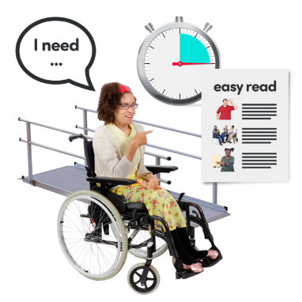 | I have a learning disability. I would like to ask for this support:
 | All written information and letters in easy read.
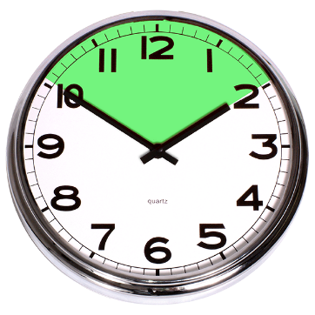 | Extra time at my appointments.
 | Allowed to bring someone with me to support me at appointments.
 | Please make sure that this is recorded on your system so other staff members know about my requests too.
There is more information here:

www.england.nhs.uk/
ourwork/accessibleinfo/

 | Please could you write to me in easy read, to let me know that my requests have been saved on your system?

Yours faithfully,

