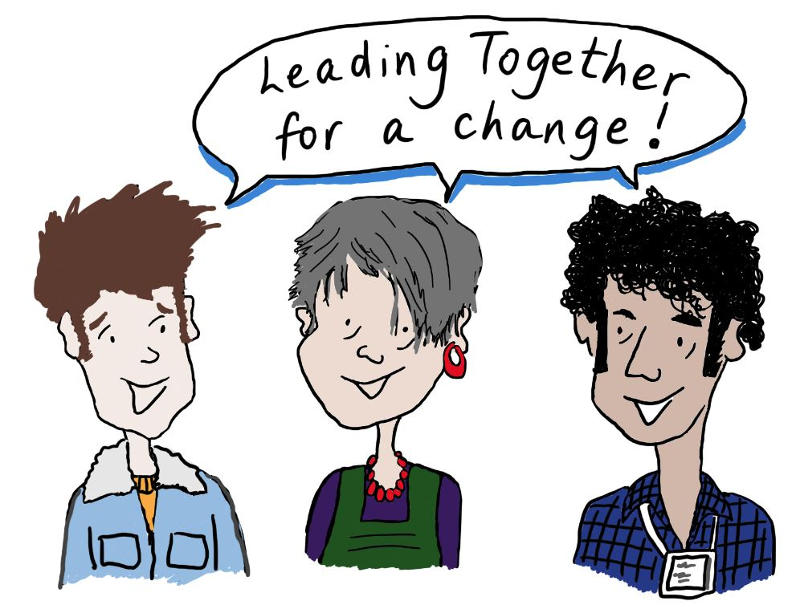

Leading Together for a Change
2019

Parent / Carers Leadership
Application Pack

Introduction

Thank you for asking for more information about the Parent Carers Leadership Course.

We will focus on “what does it take to lead together, work together, and achieve change together!” There are three course running simultaneously, this course, a course for young people and a course for professionals.

There is a lot of information in this pack. To make it easier we have split it into 2 sections.

The section called About Parent Carer Leadership tells you about the course and how to apply. Practical information - where and when the course will be held.

The section called The Application Form is for you to fill in to tell us why you would like a place.
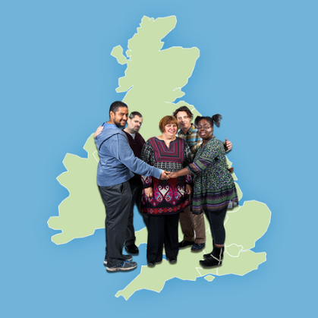

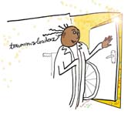

The Aim of the course:-
- Lead together
- Work together
- Achieve a change together

Who can apply for a place?
Any Parent or Carer of a child with a learning disability or Autism who lives in the North East. Although we are limited to 13 places.

Who are we looking for?
- You have an experience or interest in being a leader
- You want to work together with others to change things
- Understand the commitment to the course and be able to make the dates
- You are committed to give time outside of the course
- You want to learn and develop yourself

About the Course

The course is running for people who live in the North East & Cumbria. This will mean you live in one of the following areas:

North East & Cumbria

- Cumbria County Council
- Darlington Borough Council
- Durham County Council
- Gateshead Metropolitan Borough Council
- Hartlepool Borough Council
- North Tyneside Council
- Northumberland County Council
- South Tyneside Metropolitan Borough Council
- Sunderland City Council
- Redcar and Cleveland Borough Council
- Stockton-on-Tees Borough Council
- Newcastle upon Tyne Council
- Middlesbrough Council

Where is it?

The whole of this course will be held at:
Jurys Inn Newcastle Scotswood Road, Newcastle, NE1 4AD
https://www.jurysinns.com/hotels/newcastle/newcastle/map

When is it?

The course will start in March 2019 and run until July 2019 with a shared learning event in September and a Celebration Event in November. It is two days per month from 9:45am - 4:00pm with lunch provided.

First Sessions 20th & 21st March
Residential Session 26th& 27th April (overnight stay optional)
3rd Sessions 22nd May
4th Sessions 19th June
5th Sessions 10th July
Shared Learning event 21st September
Celebration day 9th November

Please note that the Residential weekend will involve an overnight stay however we can discuss with you if this just isn’t a possibility for your family.

The Residential session will be held at: Jurys Inn Newcastle

The rest of the course sessions will be held at:
Jurys Inn Newcastle

What will it cost?

You will not have to pay anything to come on Parent Carer Leadership Course. The course is paid for by our funders. It costs a lot of money per person but we hope that you will recognise this investment and understand why it’s important to you come to all the sessions and get the most from the course.

We will pay for your travel expenses.

What is the course about?

The Aim of the course:-
• Lead together
• Work together
• Achieve a change together

On the course, you will learn about:
✓ The history of the self advocacy movement
✓ What being a strong leader means, building resilience, Skills & Qualities
✓ How government works, and policies are made
✓ How to get your point over to people, practice speaking up
✓ Knowing your rights

You will have the chance to meet other people who are leaders in the disability movement.

You will work on a project for change alongside a young person and a professional.

We have a video about the course:
skillsforpeople.org.uk/parent-leadership-2019

How the course will be run?
The course will be run by a small group of people. The main people running the course will be:

Clare Penny-Evans Jillian Allan
There will also be lots of other people who come and share their ideas or experience
As well as listening to other people you will work in groups to share your ideas and skills.
The sessions will be about having fun as well as working hard.

Everyone who takes part in the course is asked to sign up to these values:
- The values of inclusion
- We will be honest with ourselves and each other
- Everyone has something to learn
- Everyone can contribute
- We all have prejudices we need to challenge
- Everyone has a responsibility for how they act
- Everyone is responsible for what they get out of the course
- Everyone is responsible for making the course run well

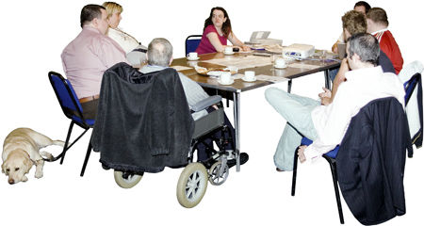
What you need to do to apply for a place.
- Fill in the application form and send it back to us or email it to us.

Email: information@skillsforpeople.org.uk
Post: Clare Penny-Evans
Skills for People
Key House
Tankerville Place
Jesmond
Newcastle upon Tyne
NE2 3AT

Closing date for applications is
18th March 2019.

- Speak to us about the content of the course if you want to know more before applying

Tel: 0191 281 8737

How we will make a decision about who gets a place.

There are places for up to 13 people on the course. We are unlikely to be able to offer a place to everyone who applies.

We will meet to look at all the applications. This will be used to shortlist so please make these as good as possible.

We will follow up with telephone calls to shortlisted applicants to ensure everything can be put in place, so you can get maximum benefit from the course.

We look forward to hearing from you!

Leadership
Application Form

Tell us one thing you have done that you are really proud of.

What experience do you have of being a leader?
This might be on a Partnership Board or in an advocacy group or another organisation.

Why do you think that you should get a place on this course?

How do you think you will use the things you have learned on this course when you get back to your area?

Please tell us the names and contact details of 2 people who will be your references – people who will back up what you say about why you should get a place on the Parent & Carer Leadership course.

Person 1 – a professional reference – someone who you have worked with to make change happen

Name:

Address:

Telephone:

Email:

Person 2 – a personal reference – someone who can tell us about your personal skills

Name:

Address:

Telephone:

Email:

Please tell us how we can get in touch with you

Your Name:

Your Address:

Telephone:

Email:

Parent & Carers Leadership in the North

Personal Information

We would like to get some information from you here about you.

We will not use this information to decide who will be given a place.

Support Needs
If you get a place, do you have any support needs?

Access Needs
If you get a place, will you need a room:
- that has no steps to it?
- that is wheelchair accessible?
Is there anything else that we will need to know to make sure the venue is accessible for you?

Cultural information
Do you need us to make a space and time for you to pray?
Is there any food that you do not eat?

Extra Information
Is there anything else that you would like us to know about you?

